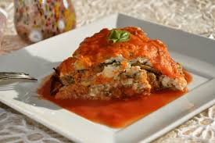

Choose firm, smooth eggplants – I baked mine rather than fried.

* 1/2 cup unsweetened applesauce with 1/2 teaspoon baking powder to replace 2 eggs

Ingredients:

Olive oil for baking sheet

2 large eggs (see NOTE above for replacement)

3/4 cup plain dry breadcrumbs

1 teaspoon dried oregano

Salt & Ground pepper

Paul Newman’s Marinara Sauce

2 large eggplants peeled and sliced

1/2 cup shredded mozzarella

Here is the rest of it CUT & PASTED. Obviously play with it and substitute where needed:

Directions
- 1. Preheat oven to 375 degrees. Brush 2 baking sheets with oil; set aside. In a wide, shallow bowl, whisk together eggs (or mixture) and 2 tablespoons water. In another bowl, combine breadcrumbs, oregano; season with salt and pepper.

2. Dip eggplant slices in egg mixture, letting excess drip off, then dredge in breadcrumb mixture, coating well; place on baking sheets. Bake until golden brown on bottom, 20 to 25 minutes. Turn slices; continue baking until browned on other side, 20 to 25 minutes more. Remove from oven; raise oven heat to 400 degrees.
3. Spread 2 cups sauce in a 9-by-13-inch baking dish. Arrange half the eggplant in dish; cover with 2 cups sauce, then 1/2 cup mozzarella. Repeat with remaining eggplant, sauce, and mozzarella. Bake until sauce is bubbling, 15 to 20 minutes. Let stand 5 minutes before serving.

